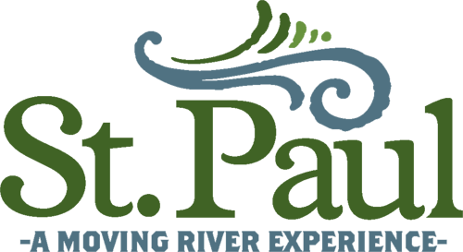
2023 Annual Drinking Water Quality Report

We're pleased to present to you the 2023 Annual Quality Water Report. This report is designed to inform you about the quality water and services we deliver to you every day. Our constant goal is to provide you with a safe and dependable supply of drinking water. We want you to understand the efforts we make to continually improve the water treatment process and protect our water resources. We are committed to ensuring the quality of your water.

We are proud to report No monitoring, reporting, PMCL, or treatment technique violations occurred in this reporting period.

Our water source is the Clinch River. The Clinch River is a surface water source that originates in Tazewell County Virginia and meanders through Russell, Wise, and Scott Counties in Virginia before entering Tennessee.

The Virginia Department of Health conducted a source water assessment of our system during 2020. The Clinch River has been determined to be of high susceptibility to contamination using the criteria developed by the state in its approved Source Water Assessment Program. The assessment report consists of maps showing the source water assessment area, an inventory of known land use activities of concern, and documentation of any known contamination within the last five (5) years. The report is available by contacting Earl Carter at the phone number or address given elsewhere in this drinking water quality report. The report will also be available at the St. Paul Town Hall, located at 16531 Russell Street.

If you have any questions about this report or concerning your water utility, please contact Earl Carter Director of Public Works, at 276-762-5297. “We want our valued customers to be informed about their water utility”. If you want to learn more, please attend any of our regularly scheduled Town Council meetings. Meetings are held on the second Monday of each month at 6:00 PM in the Town Hall. The Town Hall is located at 16531 Russell Street.

The Town of St. Paul Water Treatment Plant routinely monitors for constituents in your drinking water according to Federal and State laws. This table shows the results of our monitoring for the period of January 1st to December 31st, 2023.

All drinking water, including bottled water, may reasonably be expected to contain at least small amounts of some contaminants. The presence of contaminants does not necessarily indicate that the water poses a health risk. More information about contaminants and potential health effects can be obtained by calling the Environmental Protection Agency’s Safe Drinking Water Hotline at 1-800-426-4791.

In this table you will find many terms and abbreviations you might not be familiar with. To help you better understand these terms we've provided the following definitions:

- Action Level - The concentration of a contaminant, which, if exceeded, triggers treatment or other requirements, which a water system must follow.

- Maximum Contaminant Level or MCL - The “Maximum Allowed” (MCL) is the highest level of a contaminant that is allowed in drinking water. MCLs are set as close to the MCLGs as feasible using the best available treatment technology.

- Maximum Contaminant Level Goal or MCLG - The “goal “(MCLG) is the level of a contaminant in drinking water below which there is no known or expected risk to health. MCLGs allow for a margin of safety.

- Maximum Residual Disinfectant Level or MRDL - The highest level of a disinfectant allowed in drinking water. There is convincing evidence that addition of a disinfectant is necessary for control of microbial contaminants.

- Maximum Residual Disinfectant Level Goal or MRDLG - The level of drinking water disinfectant below, which there is no known or expected risk to health. MRDLGs do not reflect the benefits of the use of disinfectants to control microbial contaminants.

- Method Detection Limit or MDL - The minimum measured concentration of a substance that can be reported with 99% confidence that the measured concentration is distinguishable from method blank results.

- Method Reporting Limit or MRL - The MRL is the lowest reported concentration, provided on the sample-analysis data report, after corrections have been made for sample dilution, sample weight, and (for soils and sediments) amount of moisture in the sample.

- Nephelometric Turbidity Unit or NTU - nephelometric turbidity unit is a measure of the clarity of water. Turbidity in excess of 5 NTU is just noticeable to the average person.

- Non-Detect or ND - The concentration is deemed to be lower than could be detected using the method employed by the laboratory.

- Parts per Trillion or PPT or Nanograms Per Liter (ng/L) - One nanograms of substance per liter of solution is equivalent to 1x10⁻¹² kilograms per liter. 1 nanogram corresponds to one penny in one trillion dollars $1,000,000,000,000.00 dollars.

- Parts per Billion or PPB or Micrograms Per Liter (ug/L) - one part per billion corresponds to one minute in 2,000 years, or a single penny in ten million dollars $10,000,000.00

- Parts Per Million or PPM or Milligrams per liter (mg/l) - one part per million corresponds to one minute in two years or a single penny in ten thousand dollars $10,000.00

- Picocuries per liter or pCi/L - Picocuries per liter is a measure of the radioactivity in water.

- Treatment Technique or TT - A treatment technique is a required process intended to reduce the level of a contaminant in drinking water.

We have learned through our monitoring and testing that some constituents have been detected.
TEST RESULTS Regulated Contaminants
Contaminant  (Units) | Violation  Y/N | Level  Detected |  | Range |  | MCLG |  | MCL | Typical Source of Contamination |  | Date
Turbidity  (NTU) | No | < 0.3 100% of the time |  | N/A |  | N/A |  | TT, <0.3  NTU  95% | Soil runoff |  | 2023
Turbidity  (NTU) | No | 0.06 |  | 0.03-0.06 |  | N/A |  | TT  1 NTU  MAXIMUM | Soil runoff |  | 2023
Alpha emitters  (Pci/1) | No | ND |  | N/A |  | 0 |  | 15 | Erosion of natural deposits |  | 05-12  2020
Combined Radium  (Pci/1) | No | 1.5 |  | N/A |  | 0 |  | 5 | Erosion of natural deposits |  | 05-12  2020
Barium  (ppm) | No | 0.035 |  | N/A |  | 2 |  | 2 | Discharge of drilling wastes; Discharge from metal refineries; Erosion of natural deposits |  | 02-14  2023
Fluoride  (ppm) | No | 0.75 |  | N/A |  | 4 |  | 4 | Erosion of natural deposits; water additive which promotes strong teeth; discharge from fertilizer and aluminum factories |  | 02-14  2023
Nitrate plus Nitrite Nitrogène  (ppm) | No | 0.662 |  | N/A |  | 10 |  | 10 | Runoff from fertilizer use; leaching from septic tanks, seqag; erosion of natural deposits |  | 02-14  2023

TEST RESULTS Disinfectants/Disinfection by-products
Contaminant  (Units) | Violation  Y/N | Level  Detected |  | Range |  | MCLG |  | MCL | Typical Source of Contamination |  | Date
Chlorine  (ppm) | No | 1.53 |  | 1.0 – 2.0 |  | MRDG  4 |  | MRDL  4 | Water additive used to control microbes |  | 2023
Haloacetic  Acids (ppb) | No | 26 |  | 26 |  | N/A |  | 60 | By-product of drinking water disinfection |  | 7-07  2023
Total  Trihalomethane (ppb) | No | 42 |  | 42 |  | N/A |  | 80 | By-product of drinking water disinfection |  | 07-07  2023
Total Organic  Carbon  Removal Ratio | No | 1.13 |  | 0.90-1.50 |  | N/A |  | TT In  Compliance  If > or =1.0 or  Alternate criteria are met | Naturally Present in the environment |  | 2023
TEST RESULTS Lead and Copper Contaminants
Contaminant  (Units) | Violation  Y/N | Action  Level | 90th Percentile |  | MCLG |  | # Of  Sampling Sites Exceeding Action Level |  |  | Typical Source of Contamination | Date
Lead  (mg/l) | No | 0.015 | 0.000 |  | 0.0 |  | 0 |  |  | Corrosion of household plumbing systems  Erosion of natural deposits. | 09-2023
Copper  (mg/l) | No | 1.3 | 0.045 |  | 0.0 |  | 0 |  |  | Corrosion of galvanized pipes.  Erosion of natural deposits.  Leaching from wood preservatives. | 09-2023

TEST RESULTS - PFAS Contaminants (Unregulated Contaminant)
Contaminant  (Units) | Violation  Y/N | Level  Detected | Qualifier | MRL | MDL | Typical Source of Contamination | Date
PFBA  (ng/l) | No | 1.9 | J | 2.0 | 0 | Per- and polyfluoroalkyl substances (PFAS) are a group of man-made chemicals that includes PFOA, PFOS, Gen X, and many other chemicals. Examples of where PFAS can be found include cleaners, textiles, leather, paper and paints, fire-fighting foams, and wire insulation. | 06-2023
PFMPA  (ng/L | No | <0.4 |  | 2.0 | 0 | See Above Explanation. | 06-2023
PFPeA  (ng/L) | No | <1.1 |  | 2.0 | 0 | See Above Explanation. | 06-2023
PFBS  ng/L | No | 0.3 | J | 2.0 | 0 | See Above Explanation. | 06-2023
PFMBA  ng/L | No | <0.2 |  | 2.0 | 0 | See Above Explanation. | 06-2023
PFEESA  ng/L | No | <0.09 |  | 2.0 | 0 | See Above Explanation. | 06-2023
HFPO – DA  ng/L | No | <0.4 |  | 2.0 | 0 | See Above Explanation. | 06-2023
NFDHA  ng/L | No | <0.4 |  | 2.0 | 0 | See Above Explanation. | 06-2023
4:2 FTS  ng/L | No | 0.3 |  | 2.0 | 0 | See Above Explanation. | 06-2023
PFHxS  ng/L | No | 0.3 | J | 2.0 | 0 | See Above Explanation. | 06-2023
PFHpA  ng/L | No | 0.2 | J | 2.0 | 0 | See Above Explanation. | 06-2023
PFHxA  ng/L | No | 0.4 | J | 2.0 | 0 | See Above Explanation. | 06-2023
ADONA  ng/L | No | <0.2 |  | 2.0 | 0 | See Above Explanation. | 06-2023
PFPeS  ng/L | No | <0.3 |  | 2.0 | 0 | See Above Explanation. | 06-2023
6:2FTS  ng/L | No | <0.7 |  | 2.0 | 0 | See Above Explanation. | 06-2023
PFOA  g/L | No | 0.4 |  | 2.0 | 0 | See Above Explanation. | 06-2023
PHFpS  ng/L | No | <0.4 |  | 2.0 | 0 | See Above Explanation. | 06-2023
PFOS  g/L | No | 0.8 | J | 2.0 | 0 | See Above Explanation. | 06-2023
PFNA  ng/L | No | <0.2 | J | 2.0 | 0 | See Above Explanation. | 06-2023
9CL-PF3ONS  ng/L | No | <0.2 |  | 2.0 | 0 | See Above Explanation. | 06-2023
8:2 FTS  ng/L | No | <0.5 |  | 2.0 | 0 | See Above Explanation. | 06-2023
PFDA  ng/L | No | <0.2 |  | 2.0 | 0 | See Above Explanation. | 06-2023
PFUnA  g/L | No | <0.2 |  | 2.0 | 0 | See Above Explanation. | 06-2023
11CL-PF3OUdS  ng/L | No | <0.2 |  | 2.0 | 0 | See Above Explanation. | 06-2023
PFDoA  ng/L | No | <0.2 |  | 2.0 | 0 | See Above Explanation. | 06-2023

J - Is a qualifier indicating an estimated value: the value is between the Method Detection Limit and the Method Reporting Limit.

The water quality results in the above tables are from testing done in 2023. However, the state allows us to monitor for some contaminants less than once per year because the concentrations of these contaminants do not change frequently. Some of our data, though accurate, is more than one year old.

The sources of drinking water (both tap water and bottled water) include rivers, lakes, streams, ponds, reservoirs springs and wells. As water travels over the surface of the land or through the ground, it dissolves naturally occurring minerals and, in some cases, radioactive material, and can pick up substances resulting from the presence of animals or from human activity.

Contaminants that may be present in source water include:
- Microbial contaminants, such as viruses and bacteria, which may come from sewage treatment plants, septic systems, agricultural livestock operations, and wildlife;
- Inorganic contaminants, such as salts and metals, which can be naturally occurring or result from urban storm water runoff, industrial or domestic wastewater discharges, oil and gas production, mining, or farming;
- Pesticides and herbicides, which may come from a variety of sources such as agriculture, urban storm water runoff, and residential uses;
- Organic chemical contaminants, including synthetic and volatile organic chemicals, which are byproducts of industrial processes and petroleum production, and can also come from gas stations, urban storm water runoff, and septic systems.
- Radioactive contaminants, which can be naturally occurring or be the result of oil and gas production and mining activities. In order to ensure that tap water is safe to drink, EPA prescribes regulations that limit the amount of certain contaminants in water provided by public water systems. FDA regulations establish limits for contaminants in bottled water, which must provide the same protection for public health.

If present, elevated levels of lead can cause serious health problems, especially for pregnant women and young children. Lead in drinking water is primarily from materials and components associated with service lines and home plumbing. The Town of St. Paul Virginia waterworks is responsible for providing high quality drinking water, but cannot control the variety of materials used in plumbing components. When your water has been sitting for several hours, you can minimize the potential for lead exposure by flushing your tap for 30 seconds to 2 minutes before using water for drinking or cooking. If you are concerned about lead in your water, you may wish to have your water tested. Information on lead in drinking water, testing methods, and steps you can take to minimize exposure is available from the Safe Drinking Water Hotline 800-426-4791 or at http://www.epa.gov/safewater/lead .

MCLs are set at very stringent levels by the U.S. Environmental Protection Agency. In developing the standard EPA assumes the average adult drinks 2 liters of water each day throughout a 70-year life span. EPA generally sets MCLs at level that will result in no adverse health effects for some contaminants or a one-in-ten-thousand to a one-in-a-million chance of having the described health effect for other contaminants.

Some people may be more vulnerable to contaminants in drinking water than the general population. Immuno-compromised persons such as persons with cancer undergoing chemotherapy, persons who have undergone organ transplants, people with HIV/AIDS or other immune system disorders, some elderly, and infants can be particularly at risk from infections. These people should seek advice about drinking water from their health care providers. EPA/CDC guidelines on appropriate means to lessen the risk of infection by cryptosporidium and other microbiological contaminants are available from the Safe Drinking Water Hotline (1-800-426-4791).

Sodium
There is presently no established standard for sodium in drinking water. Water containing more than 270 ppm of sodium should not be used as drinking water by those persons whose physician has placed them on a moderately restricted sodium diet. Water containing more than 20 ppm should not be used as drinking water by those persons whose physician has placed them on a severely restricted sodium diet. For informational purposes, we wish to point out that the results of our most recent sampling (2023) indicate that your water has a sodium content of 8.06 ppm.

Other Information;

Cryptosporidium
In October of 2017, the St. Paul Treatment Plant (WTP) began monitoring for Cryptosporidium in the source water (before treatment) as required by EPA’s Long Term 2 Enhanced Surface Water Treatment Rule (LT2ESWTR). Cryptosporidium is a microscopic parasite found in surface water throughout the United States. Ingestion of Cryptosporidium may cause cryptosporidiosis, an abdominal infection. Although filtration removes Cryptosporidium, the most commonly-used filtration methods cannot guarantee 100 percent removal. Under the LT2ESWTR, the average Cryptosporidium concentration determines if additional treatment measures are needed. Twenty-four samples are required for analysis over a two-year period. Sampling was completed in September of 2019; the average Cryptosporidium concentration was 0.033 oocysts per liter. Based on the Cryptosporidium monitoring results and the current performance of the treatment plant, the St. Paul WTP anticipates meeting the future treatment requirements of the LT2ESWTR.
PFAS, Per- and polyfluoroalkyl substances (PFAS)

In June of 2023 our waterworks participated in a voluntary sampling program performed by the Office of Drinking Water for Per- and polyfluoroalkyl substances (PFAS). At this point this sampling is not required and all values were found to be below the EPA Reporting Limit. These chemicals are a large, complex group of man-made synthetic chemicals that includes PFOA, PFOS, Gen X, and many other chemicals that have been used in consumer products around the world since about the 1950s. They are ingredients in various everyday products. Examples of where PFAS can be found include cleaners, textiles, leather, paper and paints, fire-fighting foams, and wire insulation.

In our continuing efforts to maintain a safe and dependable water supply it may be necessary to make improvements in your water system. The costs of these improvements may be reflected in the rate structure. Future rate adjustments may be necessary in order to address these improvements.

We at the Town of St. Paul Water Treatment Plant work constantly to provide top quality water to every tap. We ask that all our customers help us protect our water sources, which are the heart of our community, our way of life and our children's future.

If I can assist you in any way, please contact me at 276-762-5297, or by email at ecarter@stpaulva.org

Earl Carter
Director of Public Works
Town of St. Paul, Virginia
================================================================================
Source Water Protection Tips

- Eliminate excess use of lawn and garden fertilizers and pesticides – they contain hazardous chemicals that can reach your drinking water source.
- Pick up after your pets.
- If you have your own septic system, properly maintain your system to reduce leaching to water sources or consider connecting to a public water system.
- Dispose of chemicals properly; take used motor oil to a recycling center.
- Volunteer in your community. Find a watershed or wellhead protection organization in your community and volunteer to help. If there are no active groups, consider starting one. Use EPA’s Adopt Your Watershed to locate groups in your community, or visit the Watershed Information Network’s How to Start a Watershed Team.
- Organize a storm drain stenciling project with your local government or water supplier. Stencil a message next to the street drain reminding people “Dump No Waste - Drains to River” or “Protect Your Water.” Produce and distribute a flyer for households to remind residents that storm drains dump directly into your local water body.

Water Conservation Tips

Did you know that the average U.S. household uses approximately 400 gallons of water per day or 100 gallons per person per day? Luckily, there are many low-cost and no-cost ways to conserve water. Small changes can make a big difference – try one today and soon it will become second nature.
- Take short showers - a 5-minute shower uses 4 to 5 gallons of water compared to up to 50 gallons for a bath.
- Shut off water while brushing your teeth, washing your hair and shaving and save up to 500 gallons a month.
- Use a water-efficient showerhead. They're inexpensive, easy to install, and can save you up to 750 gallons a month.
- Run your clothes washer and dishwasher only when they are full. You can save up to 1,000 gallons a month.
- Water plants only when necessary.
- Fix leaky toilets and faucets. Faucet washers are inexpensive and take only a few to replace. To check your toilet for a leak, place a few drops of food coloring in the tank and wait. If it seeps into the toilet bowl without flushing, you have a leak. Fixing it or replacing it with a new, more efficient model can save up to 1,000 gallons a month.
- Adjust sprinklers so only your lawn is watered. Apply water only as fast as the soil can absorb it and during the cooler parts of the day to reduce evaporation.
- Teach your kids about water conservation to ensure a future generation that uses water wisely. Make it a family effort to reduce next month's water bill!
- Visit www.epa.gov/watersense for more information.
Commode Best Practices.
There are certain things you know you shouldn't flush down the toilet. But for every obvious pick, there are a few we're all guilty of tossing in, just because we didn't realize it'd cause any issues. To ensure that your pipes stay clog-free, here are the 17 you should really, truly avoid flushing.
1. Baby Wipes. Yes, even the ones that say they're flushable; these are frequently the cause of clogs and should always be thrown out in a wastebasket instead. "Flushable" wipes don't disintegrate the way toilet paper does, which can eventually cause plumbing issues.
2. Q-Tips & Cotton Pads. Cotton balls, cotton pads, and Q-Tips are definitely not safe to flush — they don't break down the way toilet paper (even cotton toilet paper) does, all they really do is clump together in your pipes and cause problems.
3. Menstrual Products. This one might shock you, but menstrual products (tampons, pads, etc.) should never be flushed down the toilet. Why? Because, they're products that are meant to absorb water, not break down in it, meaning they'll only expand when you flush them — and that's no good for your plumbing.
4. Condoms. Condoms are also not designed to break down in water, so flushing them can cause clogs in toilets and lines.
5. Diapers. Honestly, you shouldn't even be able to flush a diaper (like menstrual products, they expand in water and diapers are probably already too big to get down the drain) but on the off-chance that you can and do, it'll expand and get caught in your pipes. That's what diaper pails are for!
6. Dental Floss. Not only can dental floss clog your pipes, it can also cause environmental damage, floss basically turns into a net when flushed, catching and holding onto other debris — it can even wrap around parts of the septic system and burn out motors.
7. Paper Towels & Tissues. You might think paper towels and tissues aren't all that different from toilet paper, but they're simply not designed to break down the way toilet paper does.
8. Medication. If you have old pills that you need to get rid of, don't flush them — toilet water doesn't break them down properly, meaning the medication gets into the water and can cause toxic environmental effects.
9. Cigarette Butts. Speaking of toxic chemicals, that's exactly what flushing cigarettes down the drain adds to the water. It’s a huge waste of water when you can simply throw them out properly. And, cigarette butts can also cause clogs.
10. Kitty Litter. Some brands of kitty litter claim to be flushable, but most toilets don't use enough water to move the litter along properly in your pipes.
11. Hair. Like dental floss, hair forms a sort of net when you flush it down the drain and gets caught on basically everything — plus, it floats, and it never dissolves in water no matter how long it's in there.
12. Gum. As you can probably imagine, chewing gum doesn't exactly break down in water, either. Plus, it's sticky and can easily adhere to the inside of your pipes and cause a clog. You should always throw gum out in the waste basket.
13. Cooking Grease. You probably already know that you shouldn't pour cooking grease down the drain, so it should make sense that the same goes for your toilet, too. Cooking grease congeals when it cools, which means it'll do the same in your pipes.
14. Fish. It seems pretty standard that people flush pet fish when they die, but this is actually not a good idea — they don't break down in water, so flushing a fish or anything like it down the toilet can absolutely cause a clog.
15. Food. This one might surprise you, because human waste is basically just broken-down food anyway, but flushing food that hasn't been digested can cause problems for your plumbing, too. Sure, it's biodegradable and will break down eventually, but it can cause clogs until that happens.
16. Bleach. Perhaps the most surprising thing you shouldn't flush is bleach. It might be a part of your regular toilet cleaning routine, but bleach is actually too harsh a chemical for your toilet and septic system.
17. Doggie/Puppy Pee Pads/Training pads. You shouldn't even be able to flush a pee pad (like menstrual products, they expand in water and pee pads are probably already too big to get down the drain) but on the off-chance that you can and do it, it'll expand and get caught in your pipes. That's what trash pails are for!
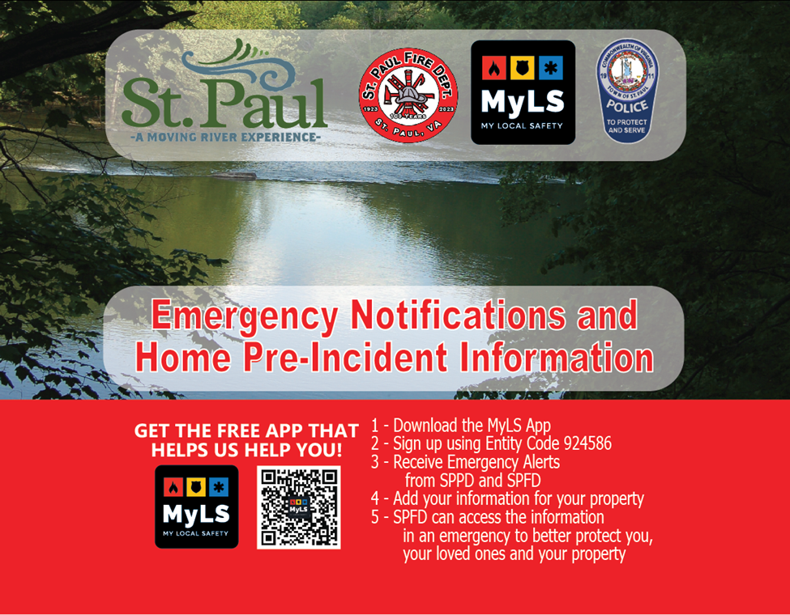

St. Paul Volunteer Fire Department is located at 16640 Russell Street, St. Paul, Virginia 24283 We have a primary service area that includes the Town of St. Paul Virginia, portions of Wise Co. including Honey Branch Bull Hill, Dwina, Russell Creek, Burtons Ford and Route 58A to Carfax Road and Russell Co. Boody, Morefield Bottom Honey Branch and Route 63 to Hanging Rock. We also cover Frosty Road and a portion of River Road.
St. Paul Fire Department is working to add EMS first response, while we won’t have ambulances, we will be able to respond with a truck stocked with first aid/response equipment and provide medical care as a licensed EMS agency.
St. Paul Fire working with the Town of St. Paul added MyLS (MyLocalSafety) to enable the fire department, police department and town to send out EMERGENCY notifications to our community. The MyLS app is no cost to the public and allows you to provide your emergency contact information and critical information about your family, pets and property in a secure manner so our fire department officers can access it. We recommend that you share the MyLS with our mutual aid partners including Castlewood Fire and Rescue, and Lebanon Fire Department. Access to your personal information is logged and tracked each time an authorized officer accesses the information with time/date stamps. This audit log is to protect that this person viewed this information to both protect the community and the agencies.
It is important to both Download the App and sign up utilizing our agency’s entity code 924586.
If you have questions, reach out to St. Paul Fire Department on Facebook or email pio@spfdva.com

